Project: Development of Capability to Model Ship Power Systems
Project Completion: 2014
Output: Modeling approaches for power systems for electric warships and performance predictions in relevant scenarios
Outcome: Navy had confidence in the support modeling needed to design and construct future ships, including emerging concepts like an energy magazine.
Project Motivation: The ESRDC research team was convinced that emerging modeling capability could support the development of more capable and less costly warships, but the documentation of the capability was not available. This project provided a foundation for more targeted approaches, such as S3D.
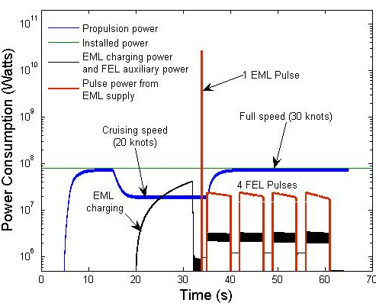
There were two significant outputs from this investigation. The first was the development of the ESRDC models for ship power systems operating at dc, 60 Hz and 240 Hz. Three different frequencies were studied because there was insufficient information available to select the best. The fundamental topology for this research is shown in Figure 1. This research demonstrated that all frequencies could be modeled and would operate successfully in an electric ship. Furthermore, it provided guidance in the choice of operating frequencies, as it permitted a direct comparison of components and, thus, of size and weight.
Figure 2: Power consumption from controlled propulsion, electromagnetic launch and laser firing.
Figure 1: Topology for ship power system modeling.
The second was the first research documenting the performance of a single storage system that provided power to an electromagnetic gun and high power laser to permit both propulsion and other high power actions. Typical information generated from modeling is shown in Figure 2. The scenario studied in Figure 2 had the ship coming up to cruising power, firing an electromagnetic gun, being detected, firing the laser defensively, and maneuvering at maximum speed. This scenario was developed in collaboration with ESRDC collaborators at the Naval Postgraduate School. This was the first simulation of the multiple use of high power storage on a naval ship, and as such, foreshadowed the current interest in an energy magazine. In addition, it was demonstrated that the storage system could be used to improve power quality at times when the electromagnetic gun and the laser are not needed.
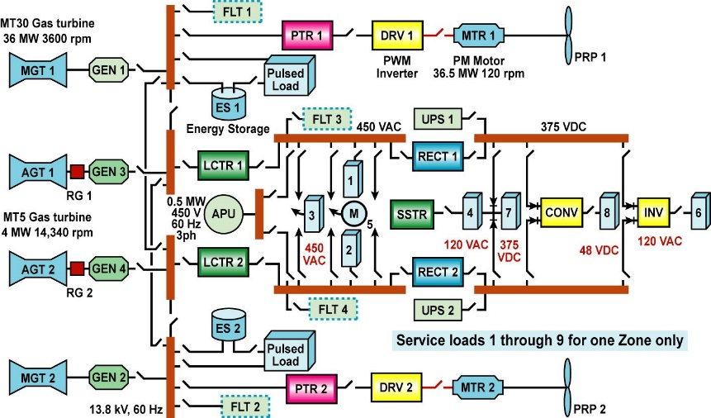
An important part of the project was the development of the modeling capability that led to these research outputs. The initial simpler topology that was used to develop and demonstrate capability is shown in Figure 3. This model, albeit simpler than those used in later work, was important because it includes most of the key components in a realistic topology. This model was initially solved in Matlab/Simulink, a commercial solver. To address concerns about the effectiveness of commercial codes, the same ship system was modeled in three appropriate computer programs. As expected, the three provided the information within the expected uncertainty of the process. Matlab/Simulink was selected for the preponderance of this work at the request of a committee representing the ship yards. Since it appeared that a range of commercial codes were applicable, they preferred that Matlab/Simulink be used when possible because it was familiar to nearly all of their engineers.
Figure 3: Initial system used to develop and demonstrate modeling capability.
Project Extent: This project involved researchers from four ESRDC member institutions as well as the Naval Postgraduate School and is documented in ten technical papers and reports.
Technical Point of Contact: Dr. A. Ouroua, a.ouroua@cem.utexas.edu

