Project: Effective Ship Power System Simulation
Project Completion: 2014
Output: Technology to reduce computational time when modeling ship power systems.
Outcome: Navy had a critical tool needed to improve ship design and performance leading to a more capable fleet.
Project Motivation: An important contributor to U.S. military superiority has been the continued superiority in computing. For the last few decades, military superiority in this area has rested in a large part on Moore’s Law, which is a description of the fact that investment in appropriate semiconductor technology led to better performance. The Department of Defense learned to exploit this rapid change in technology even though it did not fit well with its budget or procurement cycles.
However, Moore’s Law growth has ended. On a purely technological level, we can still double the density of the components on a processor chip, but it does not lead to sufficient system improvement to warrant the investment. So, the Department of Defense, as well as companies needing a competitive advantage, find other solutions.
The ESRDC was early in recognizing the issue because the development of future ships that are efficient, effective, and employ emerging technology requires exhaustive (and detailed) simulation before and after their construction. Today, however, it is costly to conduct the required simulations of large shipboard models due to the length of time required to complete the calculations when using commercial software and desktop computers.
Three approaches were explored by the ESRDC. The first approach, the use of special purpose computers, was rejected due to the high cost of ownership, even if successful. The second was the use of field-programmable gate arrays. This technology offers appealing computational speed increases, but ONR was already funding others in this area and their progress was too slow to benefit this program. The ESRDC took the third available research path – using low-cost, commercially available desktop computers with multi-core -processors for parallel processing. This is the same approach being used at super-computing centers to achieve ultimate performance.
To use multi-core processors, a simulation problem must be partitioned so that the processors can work efficiently in parallel. One breakthrough of CEMSolver was to use graph-partitioning software to overcome that problem. This mathematical process can be performed by the computer without requiring the operator to have knowledge of graph or circuit theory. Another breakthrough, which followed partitioning, was to reformulate models by using appropriate boundary conditions to make each partition perform electrically as it would in the unpartitioned system. Again, this is all done silently in software with no intervention by the operator. A key advantage was to retain the familiar Matlab/Simulink interface, but a much more sophisticated solution is achieved in less time.
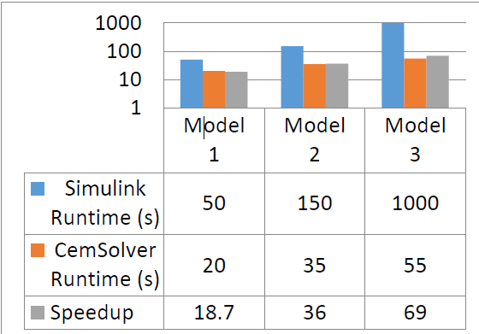
Sample accelerations are shown in Figure 1, where the vertical axis indicates the number of nodes or single-phase buses in the circuit whose performance was simulated. To put the data in context of simulation time, Model 3 took about 20 minutes using Matlab/Simulink, but only 55 seconds using CEMSolver. In both cases, the operator developed the circuit in Matlab/Simulink and the computer used the CEMSolver rather than the solvers embedded in Matlab/Simulink to do the simulation. So, while the complexity is transparent to the user, the benefit is very apparent.
Since the accuracy of a simulation is also important, accuracy assessments were contrasted against commercial simulators. In this case, it was deemed acceptable to assess relative accuracy with Matlab/Simulink, as that is a commercial product that is widely used and generally produces trusted results. Comparing the results on the same circuit between Matlab/Simulink and CEMSolver suggests that the enhanced speed of CEMSolver does not degrade the accuracy.
Figure 1: Three samples of computation speed increases over conventional solution approaches.
Although CEMSolver only accelerates the simulation of electrical network models, shipboards include controls as well. To address this aspect, ESRDC researchers developed a complimentary solver named MSUSolver, which solves the controls portion of a model, while CEMSolver solves the electrical portion of a model. Both solvers work in unison to produce a holistic solution.
Significant progress was made in four areas:
- Accelerating the simulation of shipboard power systems
Accelerations as high as 78x have been measured in circuits with relevant levels of complexity.
- Assessing the confidence in the accuracy of the accelerated simulations
The comparisons showed that simulating large shipboard systems get the results faster with no reduction in accuracy when compared to commercial solutions.
- Providing benchmarks for industrial development
Collaboration with commercial suppliers of software has guided this work and provided benchmarks for the developers of both commercial and open source software.
- Simulation of dc systems
The dc system work brought together, for the first time, the combined power grid and control system simulation. In addition, it showed the approach was robust with respect to the simulation of solid-state switching, a key requirement for dc system simulations.

Project Extent: This project involved researchers from two ESRDC member institutions and is documented in several technical papers, a report, and a textbook.
Technical Point of Contact: Dr. Robert Hebner, r.hebner@cem.utexas.edu

