Project: Thermal-Electrical Co-simulation
Project Completion: 2012
Output: Documentation of the interaction between the thermal and electrical performance for anticipated components in electric ships. Development of technology and a modeling approach that permits assessments in emerging components.
Outcome: Reduced the risk in ship design through quantitative assessment of interoperability challenges.
Project Motivation: A critical impediment to efficient electric ship design has been the modeling challenge to couple the electrical and thermal behavior. In operation, however, they are closely coupled and critically interdependent. That impediment has been removed. This research shows that coupled solutions are possible in modern simulation systems.

Currently, the Arleigh Burke DDG-51 class destroyer employs five 200-ton marine chiller units to handle active cooling of ship systems and components. Every shipboard component, from the smallest processor chip to the largest gas turbine, contributes dynamically to this thermal management challenge due to the generation of “waste heat” that must be managed. On average, approximately 681 tons of waste heat is rejected from an Arleigh Burke class warship. However, this average value does not capture the magnitude of peak waste heat during transient situations.

On a highly dynamic, controls-oriented, future ship steady-state values provide little utility from a reconfiguration or system failure perspective. When a fully capable all electric ship is deployed, shipboard cooling requirements are predicted to increase by as much as 700%, not including the integrated effects of dynamic power buildup and adaptive grid response following the introduction of high-energy weapons and sensors. It is the objective of the research reported in this paper to simulate shipboard thermal load management from a dynamic, controls-based, system-level perspective.

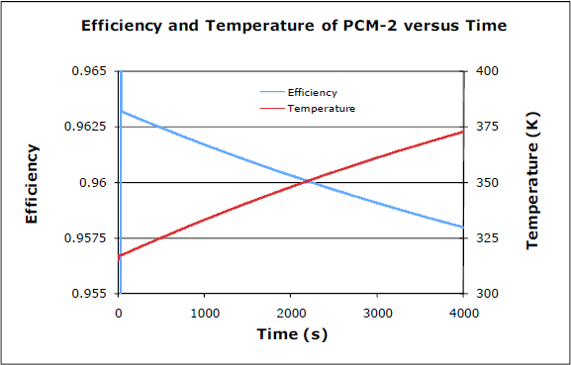
An example of the interaction of thermal and electrical interaction is given in Figure 1, which shows the results of a thermal and electrical co-simulation of an inverter, sometimes referred to as a PCM-2.. Even though the inverter has a thermal management system, the temperature rises during operation. That temperature rise reduces the efficiency of the inverter, which contributes to the observed temperature increase.
Figure 1: Co-simulation of an inverter showing the interaction between temperature and electrical operation.

The development of this modeling capability provides the ability to assess the effects of various design choices. For example, Figure 2 shows the effects of specific air-cooled and water-cooled thermal management approaches for the circuit whose analysis results are presented in Figure 1. The efficiency is important because studies funded by the Department of Energy
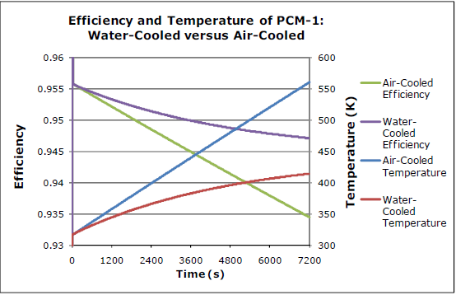
show that as the efficiency of the power electronics decreases the efficency advantage of dc distribution over ac distribution also decreases.

So, ESRDC researchers developed a general purpose simulation tool, the DTMS framework, that was specifically intended to address the US Navy’s need for design-oriented characterization of thermal interactions with high power, mechanical-electrical components notionally planned for their future all-electric ships.
Figure 2: Quantitative prediction of the effects of two thermal approaches on the operating temperature and, consequently, on efficiency.

The project also demonstrated the use of DTMS in system-level simulations, e.g., an integrated electric propulsion system, chiller-based management of shipboard loads, capacitor-based electromagnetic gun, co-simulation of power conversion modules that form an electrical power system, and optimal control approach for a marine chiller that is directly applicable to other shipboard systems.

The DTMS framework came about because of the need to understand the dynamics of system-level thermal management. However, as system-level simulations in DTMS have become more complex, the need for more sophisticated control techniques has increasingly become apparent. Without a more sophisticated controls approach, it is the responsibility of the user to find suitable control coefficients for every controller in a simulation. When only one or two controllers are implemented, as in a standalone chiller simulation, this process is straightforward. However, simulations featuring many controllers, with many active loads, present real challenges. In addition, the adjustment of other user-defined parameters (design mass flow rates, initial conditions, etc.) affects control relationships as well.

Before any attempt to simulate highly dynamic all-electric ship scenarios, it is recognized that a more robust control strategy must be developed and implemented. For example, allowing the user more freedom in controller type and open/closed loop setup would provide more flexibility in achieving stability and accuracy requirements. More sophisticated control analysis techniques, such as frequency response plotting and Model Predictive Control, could provide more effective tuning methods. In addition, advanced control approaches could streamline the interactions of several controllers into a single response. These approaches, and others, should be investigated in future work.

Project Extent: This project involved researchers from the University of Texas at Austin and is documented in five technical papers and a report.
Technical Point of Contact: Dr. R. Hebner, r.hebner@cem.utexas.edu
