***Project:*** Dynamic Reconfiguration of Ship Power Systems

***Project Completion:*** 2006

***Output:*** Technical papers and reports that demonstrated an effective approach to the successful reconfiguration of a ship power system.

***Outcome:*** The Navy had confidence that at least one comprehensive approach to power system reconfiguration was available. Without such capability, electric ships would be much less useful.

***Project Motivation***: A key discriminator for an all-electric ship is that the power system can, in principle, be rapidly reconfigured from a cruise mode to a battle mode or to maintain maximum capability during damage as was experienced by the USS Cole. This research identified an approach to achieving that reconfiguration, and identified some limitations and constraints that are inherent in ship power systems. There are two fundamental approaches that can be explored. One approach is a bottom up line of attack, as might be taken with intelligent agents. Agents may be designed to target a subset of the problem and are equipped with essential functionality, such as the ability to communicate with neighboring agents. They might, for example, ask if their control region has the ability to share some of its power with its neighbors.

The second approach, and the one that was used in this research, is top down. Decisions are based on global information gathered throughout the ship power system. Control action at this level may be directly related to mission-specific needs and requirements, which must be reconciled with the existing state of the power system. This leads to decisions about reconfiguration. While this approach has some commonality with approaches that have been valuable for electric utilities, this is much more automated and sophisticated. The ship is small compared to a common grid making the latency limitations much smaller. In summary, the approach is:

1. Determine the equivalent impedance configuration for the system.
2. Run an optimization algorithm to determine the configuration that best uses the system resources, meets critical power demands, and minimizes losses.
3. Progress to the favored state through the most direct stable path, minimizing switching transients.
4. Repeat the process as soon as the switching transients have sufficiently decayed.

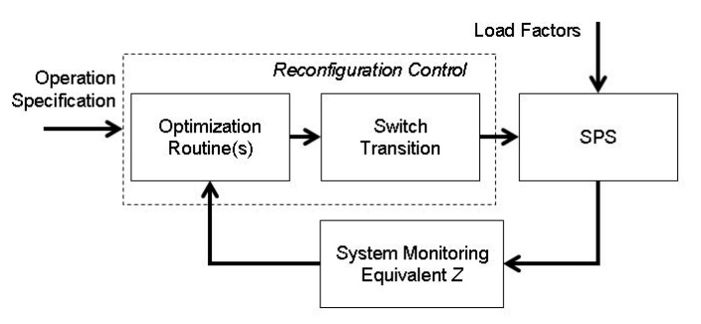 This approach is summarized in Figure 1. The research shows that step 1 can typically be completed in 5-10 ms and the entire process is possible in 100-150 ms. The times depend on the computing power available and the system complexity. The demonstration, in which the research team conducted on a small computer using a simulated ship power system, exhibited operating times of about 7 ms and 150 ms. Not only was the demonstration successful in documenting the fundamental performance of the reconfiguration algorithms that were developed, it also provided the identification of important shipboard constraints. The first constraint is to balance the system complexity with the computing power available to inform timely decisions. With the consistent growth in available computing power, it is expected this will be a lessening constraint over time. Second, reconfiguration that leads to line failure must be avoided. This constraint led to a research that showed that initial selection of line sizes based both on the initial use and on the possibility of reconfiguration can lessen this constraint.

**Figure 1: Summary of reconfiguration approach. "SPS" stands for ship power system.**

The third constraint is generator loading. If the load on the generator plant changed due to reconfiguration, the number and size distribution of gas turbines on line will likely change. Optimal generator selection will likely require some storage to provide time for changes in generation when needed.

The final constraint is that the transition to the new power system state must be both stable and as close as possible to optimal. During reconfiguration, every possible switching configuration is considered, not just the normal and faulted scenarios. Rather than working with the highly nonlinear dynamics of the system, linearizing the singularly perturbed system model of each configuration around its respective equilibrium was shown to be reasonable and the analysis is greatly simplified.

total_fuelA shipboard power system being self-contained and tightly coupled is small enough to allow nearly real time state estimation, given appropriate equivalent circuit representations. Redirecting power flow is the preeminent task of reconfiguration. This redirection can be accomplished in less than 150 ms without compromising system stability or power delivery to critical loads. These performance objectives can be approached using an equivalent impedance system representation and various optimization procedures. This reconfiguration control has been demonstrated using a Matlab Simulink© simulation and more powerful software should improve the system performance. The research showed that there are issues concerning the proper realization of a reconfigurable power system by incorporating a gas turbine status. Furthermore, due consideration for stable and safe transition between different power system states are critical in a practical reconfiguration effort.

**Figure 2: Static optimization is overly optimistic. For an LM 2500 gas turbine, the dynamic reconfiguration shows the actual fuel cost while a static optimization ignores that cost, effectively assuming there is none.**

***Project Extent***: This project involved multiple researchers from one ESRDC institution and is documented in five technical papers and a report.

***Technical Point of Contact***: Dr. R. Hebner, [r.hebner@cem.utexas.edu](mailto:r.hebner@cem.utexas.edu)

