Project: Electric Ship-board Design for High Reliability Metrics
Project Completion: 2017
Output: A framework to evaluate the reliability metrics of a given shipboard topology is developed. The reliability of nominal shipboard topologies such as ring bus, breaker-and-a-half and double bus double breaker are compared using the framework. Based on the analysis, the factors that influence the reliability of a given topology are determined. Additionally, new design modifications for zonal electrical distribution (ZED) system are recommended to the nominal topologies to improve its reliability metrics.
Outcome: The Navy has a new approach to enhance ship reliability in the design process.
Project Motivation: Ensuring the continuity of service in shipboard power system (SPS) in an all-electric ship is of paramount importance. A failure of the shipboard power system can result in critical loads, such as radar, weapons, and propulsion motors, being left without service until repairs can be performed. This work calculates, compares, and improves the reliability metrics of an SPS.

First, the ESRDC researchers developed a method to compute the service reliability of a ship’s primary and (ZED) systems. The service reliability of the primary distribution system is quantified using expected frequency and the duration of service interruptions to equipment loads caused by the component failure. As for ZEDs, the service reliability is quantified in terms of network availability and is defined as the steady-state probability of a network being in the operational state. The network availability is computed using the minimal paths (minpaths) of the distribution network. A minpath is a set of nodes and edges that characterize an operational network, but the removal of any one edge results in a loss of service. Such a case is defined as a network failure.

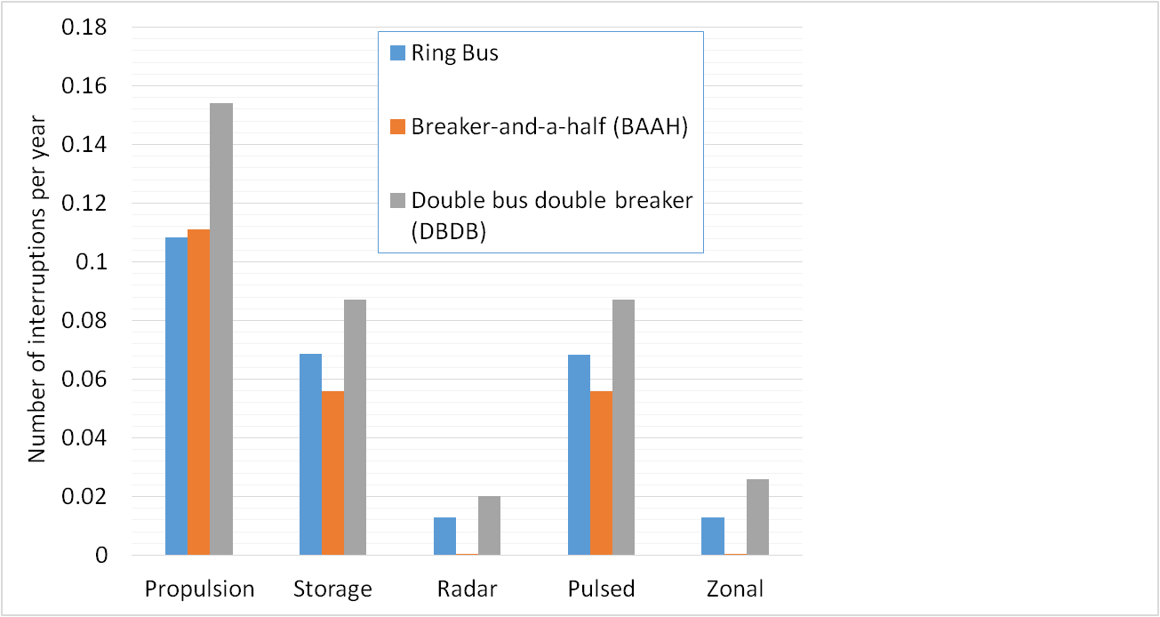
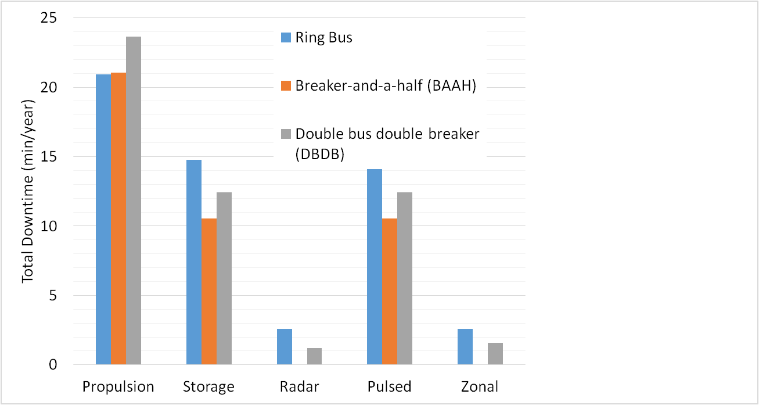
Using the developed reliability calculation framework, several notional distribution system topologies are compared for both primary and ZED systems. The reliability of primary distribution system topologies based on ring bus, breaker-and-a-half (BAAH), and double-bus double-breaker (DBDB) are compared and presented in Fig.1. Based on the analysis, it is observed that a breaker-and-a-half-based topology results in maximum reliability, outperforming the other two topologies. Next, the network availability resulting from radial, loop, and grid topologies for a 15-node ZED are compared (shown in Fig. 2). The radial topology is calculated to be available with a probability of 0.75 using 14 conductors. By adding only two conductors, however, a loop topology is obtained with a network availability of about 0.98. Due to several alternate paths, the grid topology results in the maximum number of operational networks and, therefore, maximum network availability (more than 0.99).
Figure 1 Equipment interruption rates and total downtime for ring bus, BAAH, and DBDB topologies.
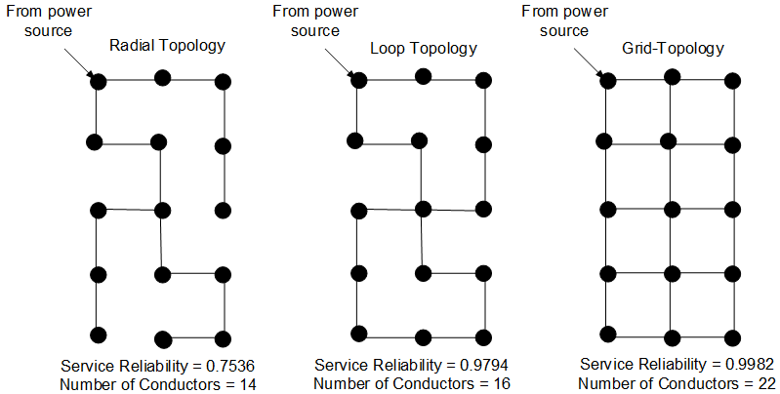
Next, methods to improve service reliability, both for the ship’s primary distribution system and the ZED system, are explored. For the primary distribution system, the reliability improvements obtained by optimal placement of equipment loads and generation units within an existing topology are investigated. The reliability gains obtained by providing additional in-feeds to a ship’s critical loads, such as pulsed loads or radar, are also demonstrated. When adding one additional in-feed to the pulsed load, the ship's overall system interruption rate decreases by 37.5%. Furthermore, we investigated the reliability gains obtained by extending a ship’s primary distribution system topology to a three-dimensional (3D) structure. A primary distribution system topology, such as a BAAH topology, can be extended into a 3D structure by distributing a ship’s equipment loads to different planes of the ship where each plane is designed in a BAAH topology and connecting different planes using vertical tie-buses. Several 3D topologies based on ship’s planar topologies, such as ring bus and BAAH, are simulated, and the reliability comparisons are made against the respective planar topologies. Compared to planar topologies, 3D topologies slightly decrease the overall service interruption rates for each notional topology, thus improving the service reliability. Additionally, a 3D topology provides a more robust structure for the SPS. Since equipment loads are distributed in different decks of the ship, if one of the ship’s decks is destroyed during an attack, loads located in another deck may remain functional.
Figure 2 Comparing ZED circuit topologies; a) Radial, b) Loop, and c) Grid
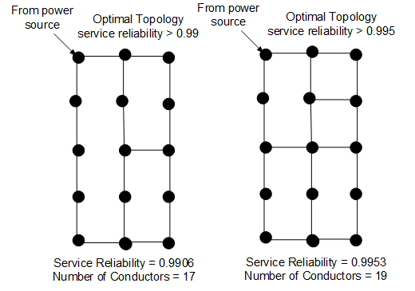
To ensure the highest possible level of service availability, a ship’s ZEDs are usually designed in a grid topology. A grid topology, however, uses a large number of conductors, thus significantly increasing cost and space requirements. Given the limited space in an SPS, we aim to design a ZED topology that uses fewer conductors than in a grid topology while satisfying the required network availability constraint. The circuit topology with a network availability of more than 0.99 is obtained by using 17 and 19 conductors which is 5 and 3 conductors fewer compared to the corresponding grid topology for 15 node circuit (refer Fig. 3). By designing the circuit topology, this work prioritizes network availability as the design objective and thus presents a new approach to the distribution circuit design problem.

Figure 3 Optimal ZED circuit topology with Rel(G) >; a) 0.99, and b) 0.995
Project Extent: This project involved researchers from an ESRDC member university and is documented in five technical papers and a report.
Technical Point of Contact: Dr. Surya Santoso, ssantoso@mail.utexas.edu

