Converter module

Macro file name: SSCM.mac
Macro name: SSCM, NLAM_SSCM
Version number: NCS 3.1

Brief Description
The ship service converter module regulates the in-zone bus voltage. The topology of the converter module is shown in Figure 1. Voltage regulation is achieved through a combination of the feedback and feed forward control paths that are shown in Figure 2. In addition, a droop setting is used to regulate the sharing between converter modules within each zone. Also implemented is a stabilizing filter that acts to counteract the destabilizing influence of constant power loads [1]. The output of the regulator is a commanded inductor current that is used for hysteresis-based switch-level control.

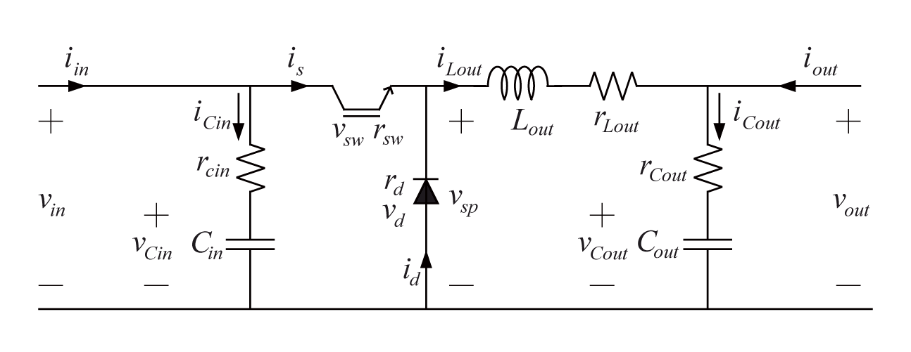
Fig 1. Converter Module

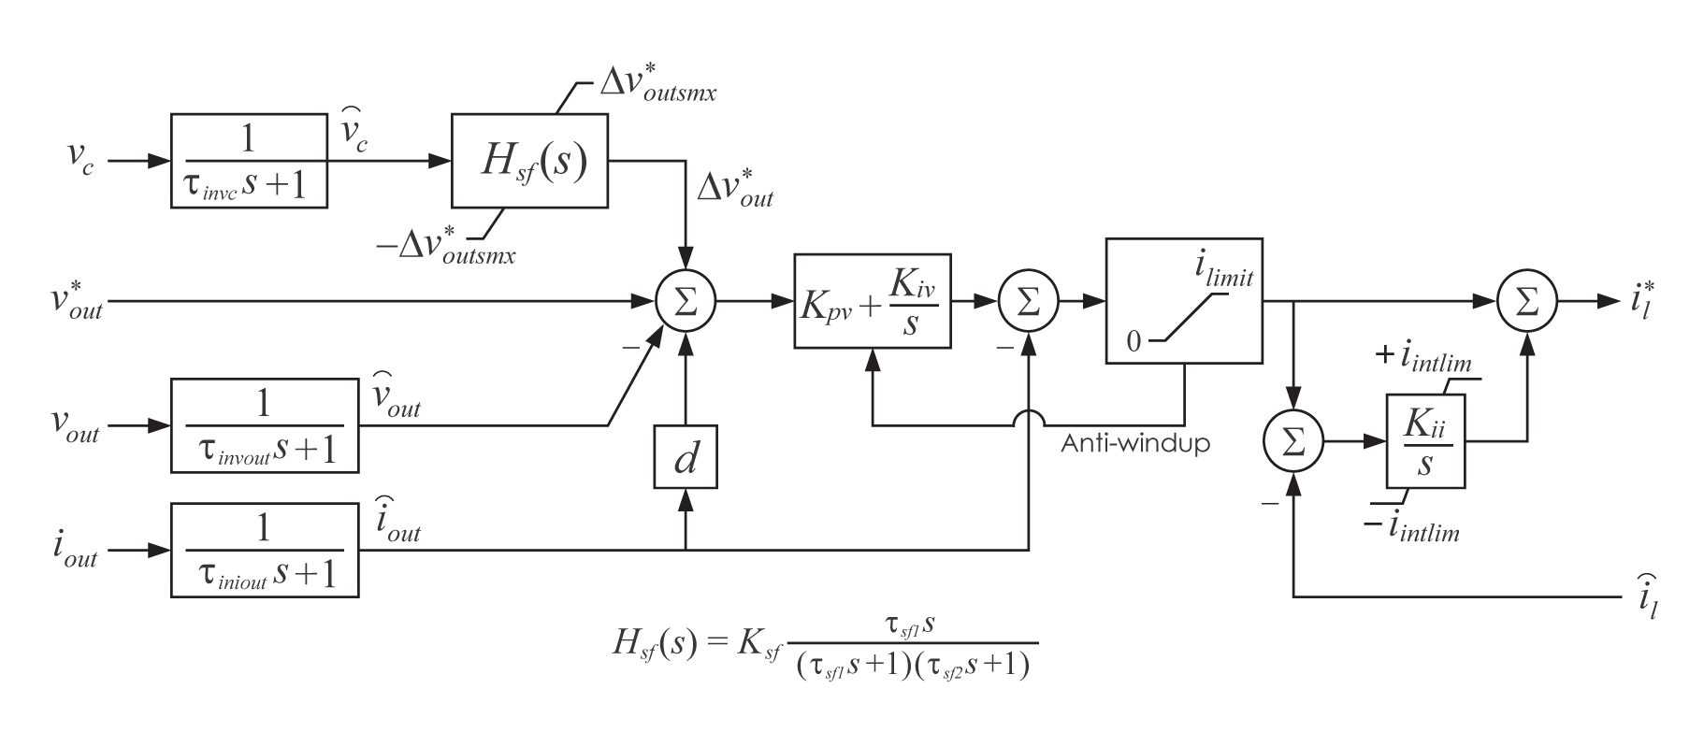
Fig 2. Converter Module Controller

SSCM is for the detailed model and NLAM_SSCM is for the nonlinear average version.

Reference
- S.D.Sudhoff, et. al, “Stability Analysis Methodologies for DC Power Distribution Systems,” Proceedings of the Thirteenth Ship Control Systems Symposium (SCSS 2003), Orlando, Florida, April 7-9, 2003.

SSCM: Detailed model of the ship service converter module

Author: S. D. Sudhoff
Author contact: sudhoff@purdue.edu,
Date:
Macro name: SSCM
Version number: NCS 3.1
Report errors or changes to: sudhoff@purdue.edu

Brief Description

Detailed model of a ship service converter module.

List of Inputs, Outputs, Parameters, and Internal variable
Variable Name | Description | Units
z | Concatenation variable

Input Variable Name | Description | Units
on | Logical command to turn on converter | logical
off | Logical command to turn off converter | logical
$$u_{\text{in}}$$ | Input port input variable | V/A
$$u_{\text{out}}$$ | Output port input variable | V/A

Output Variable Name | Description | Units
$$v_{\text{in}}$$ | Input port voltage | V
$$i_{\text{in}}$$ | Current into input port | A
$$v_{\text{out}}$$ | Output port voltage | V
$$i_{\text{out}}$$ | Current into output port | A
$$v_{{\text{in}}_{\text{thev}}}$$ | Input port instantaneous Thevinen equivalent circuit voltage | V
$$r_{{\text{in}}_{\text{thev}}}$$ | Input port instantaneous Thevinen equivalent circuit resistance | Ω
$$v_{{\text{out}}_{\text{thev}}}$$ | Output port instantaneous Thevinen equivalent circuit voltage | V
$$r_{{\text{out}}_{\text{thev}}}$$ | Output port instantaneous Thevinen equivalent circuit voltage | Ω

Parameter Name | Description | Default Value | Units
$$v_{\text{in}\text{min}1}$$ | Lowest input capacitor voltage to start converter |  | V
$$v_{\text{in}\text{max}1}$$ | Highest input capacitor voltage to start converter |  | V
$$v_{\text{in}\text{min}2}$$ | Lowest input capacitor voltage to keep running |  | V
$$v_{\text{in}\text{max}2}$$ | Highest input capacitor voltage to keep running |  | V
$$τ_{\text{sc}}$$ | Time constant of supervisory control |  | sec.
$$v_{\text{out}}^{}$$ | Desired DC output voltage |  | V
$$d$$ | Droop setting |  | V/A
$$k_{\text{pv}}$$ | Proportional gain of voltage control |  | A/V
$$k_{\text{iv}}$$ | Integral gain of voltage control |  | A/V/s
$$i_{\text{lim}\text{it}}$$ | Current limit of inductor current command |  | A
$$k_{\text{ii}}$$ | Integral gain of current control |  | A/A/s
$$i_{\text{intlim}}$$ | Limit on integral term in current control |  | A
$$τ_{\text{invc}}$$ | Capacitor voltage measurement input filter time constant |  | sec.
$$τ_{\text{invout}}$$ | Output voltage measurement input filter time constant |  | sec.
$$τ_{\text{iniout}}$$ | Output current input filter time constant |  | sec.
$$k_{\text{sf}}$$ | Stabilizing filter bandpass gain
$$τ_{\text{sf}1}$$ | Stabilizing filter low pass time constant |  | sec.
$$τ_{\text{sf}2}$$ | Stabilizing filter high pass time constant |  | sec.
$${ΔV}_{\text{outsmx}}$$ | Limit of stabilizing feedback output voltage perturbation command |  | V
modconfig | Model configuration  1: $u_{\text{in}}$= $v_{\text{in}}$,$u_{\text{out}}$=$v_{\text{out}}$  2: $u_{\text{in}}$= $v_{\text{in}}$,$u_{\text{out}}$=$i_{\text{out}}$  3: $u_{\text{in}}$= $i_{\text{in}}$,$u_{\text{out}}$=$i_{\text{out}}$  4: $u_{\text{in}}$= $i_{\text{in}}$,$u_{\text{out}}$=$v_{\text{out}}$
$$v_{\text{sw}}$$ | Switch nominal forward voltage drop |  | V
$$r_{\text{sw}}$$ | Switch forward resistance |  | Ω
$$v_{d}$$ | Diode nominal forward voltage drop |  | V
$$r_{d}$$ | Diode forward resistance |  | Ω
$$C_{\text{in}}$$ | Input capacitor capacitance |  | F
$$r_{\text{Cin}}$$ | Effective resistance of input capacitor |  | Ω
$$L_{\text{out}}$$ | Output inductor inductance |  | H
$$r_{\text{Lout}}$$ | Output inductor resistance |  | Ω
$$C_{\text{out}}$$ | Output capacitor capacitance |  | F
$$r_{\text{Cout}}$$ | Output capacitor effective series resistance |  | Ω
h | Hysteresis band |  | A

Internal Variable Name | Description | Units
s | Transistor gate status
$$i_{\text{Lout}}$$ | Current in output inductor | A
$$i_{l}^{}$$ | Commanded inductor current | A

Macro format

MACRO SSCM(z, on,off,uin,uout, &
vin,iin,vout,iout,vin_thv,rin_thv,vout_thv,rout_thv, &
par_vinmin1,par_vinmax1, &
par_vinmin2,par_vinmax2,par_tausc, &
par_voutstar,par_d, &
par_kpv,par_kiv,par_ilimit, &
par_kii,par_iintlim, &
par_tauinvc,par_tauinvout,par_tauiniout, &
par_ksf,par_tausf1,par_tausf2,par_dvoutsmx, &
par_modconfig, &
par_vsw,par_rsw,par_vd,par_rd, &
par_cin,par_rcin,par_lout,par_rlout, &
par_cout,par_rcout, &
par_h)

Validation
This model has been validated via hardware experimentations.

NLAM_SSCM: Nonlinear average value model of a ship service converter module

Author: S. D. Sudhoff
Author contact: sudhoff@purdue.edu,
Date:
Macro name: NLAM_SSCM
Version number: NCS 3.1
Report errors or changes to: sudhoff@purdue.edu

Brief Description

Nonlinear average value model of a ship service converter module.

List of Inputs, Outputs, Parameters, and Internal variable
Variable Name | Description | Units
z | Concatenation variable

Input Variable Name | Description | Units
on | Logical command to turn on converter | logical
off | Logical command to turn off converter | logical
$$u_{\text{in}}$$ | Input port input variable | V/A
$$u_{\text{out}}$$ | Output port input variable | V/A

Output Variable Name | Description | Units
$$v_{\text{in}}$$ | Input port voltage | V
$$i_{\text{in}}$$ | Current into input port | A
$$v_{\text{out}}$$ | Output port voltage | V
$$i_{\text{out}}$$ | Current into output port | A
$$v_{{\text{in}}_{\text{thev}}}$$ | Input port instantaneous Thevinen equivalent circuit voltage | V
$$r_{{\text{in}}_{\text{thev}}}$$ | Input port instantaneous Thevinen equivalent circuit resistance | Ω
$$v_{{\text{out}}_{\text{thev}}}$$ | Output port instantaneous Thevinen equivalent circuit voltage | V
$$r_{{\text{out}}_{\text{thev}}}$$ | Output port instantaneous Thevinen equivalent circuit voltage | Ω

Parameter Name | Description | Default Value | Units
$$v_{\text{in}\text{min}1}$$ | Lowest input capacitor voltage to start converter |  | V
$$v_{\text{in}\text{max}1}$$ | Highest input capacitor voltage to start converter |  | V
$$v_{\text{in}\text{min}2}$$ | Lowest input capacitor voltage to keep running |  | V
$$v_{\text{in}\text{max}2}$$ | Highest input capacitor voltage to keep running |  | V
$$τ_{\text{sc}}$$ | Time constant of supervisory control |  | sec.
$$v_{\text{out}}^{}$$ | Desired DC output voltage |  | V
$$d$$ | Droop setting |  | V/A
$$k_{\text{pv}}$$ | Proportional gain of voltage control |  | A/V
$$k_{\text{iv}}$$ | Integral gain of voltage control |  | A/V/s
$$i_{\text{lim}\text{it}}$$ | Current limit of inductor current command |  | A
$$k_{\text{ii}}$$ | Integral gain of current control |  | A/A/s
$$i_{\text{intlim}}$$ | Limit on integral term in current control |  | A
$$τ_{\text{invc}}$$ | Capacitor voltage measurement input filter time constant |  | sec.
$$τ_{\text{invout}}$$ | Output voltage measurement input filter time constant |  | sec.
$$τ_{\text{iniout}}$$ | Output current input filter time constant |  | sec.
$$k_{\text{sf}}$$ | Stabilizing filter bandpass gain
$$τ_{\text{sf}1}$$ | Stabilizing filter low pass time constant |  | sec.
$$τ_{\text{sf}2}$$ | Stabilizing filter high pass time constant |  | sec.
$${ΔV}_{\text{outsmx}}$$ | Limit of stabilizing feedback output voltage perturbation command |  | V
modconfig | Model configuration  1: $u_{\text{in}}$= $v_{\text{in}}$,$u_{\text{out}}$=$v_{\text{out}}$  2: $u_{\text{in}}$= $v_{\text{in}}$,$u_{\text{out}}$=$i_{\text{out}}$  3: $u_{\text{in}}$= $i_{\text{in}}$,$u_{\text{out}}$=$i_{\text{out}}$  4: $u_{\text{in}}$= $i_{\text{in}}$,$u_{\text{out}}$=$v_{\text{out}}$
$$v_{\text{sw}}$$ | Switch nominal forward voltage drop |  | V
$$r_{\text{sw}}$$ | Switch forward resistance |  | Ω
$$v_{d}$$ | Diode nominal forward voltage drop |  | V
$$r_{d}$$ | Diode forward resistance |  | Ω
$$C_{\text{in}}$$ | Input capacitor capacitance |  | F
$$r_{\text{Cin}}$$ | Effective resistance of input capacitor |  | Ω
$$L_{\text{out}}$$ | Output inductor inductance |  | H
$$r_{\text{Lout}}$$ | Output inductor resistance |  | Ω
$$C_{\text{out}}$$ | Output capacitor capacitance |  | F
$$r_{\text{Cout}}$$ | Output capacitor effective series resistance |  | Ω
$$k_{\text{heff}}$$ | Effective gain of hysteresis control (1/A)  (should be high enough that current is tracked) |  | 1/A

Internal Variable Name | Description | Units
m | Switching duty cycle
$$i_{\text{Lout}}$$ | Current in output inductor | A
$$i_{l}^{}$$ | Commanded inductor current | A

Macro format

MACRO NLAM_SSCM(z,on,off,uin,uout, &
vin,iin,vout,iout, &
vin_thev,rin_thev,&
vout_thev,rout_thev, &
par_vinmin1,par_vinmax1, &
par_vinmin2,par_vinmax2,par_tausupc, &
par_voutstar,par_d, &
par_kpv,par_kiv,par_ilimit, &
par_kii,par_iintlim, &
par_tauinvc,par_tauinvout,par_tauiniout, &
par_ksf,par_tausf1,par_tausf2,par_dvoutsmx, &
par_modconfig, &
par_vsw,par_rsw,par_vd,par_rd, &
par_cin,par_rcin,par_lout,par_rlout, &
par_cout,par_rcout, &
par_kheff)

Validation
This model has been validated via hardware experimentations.

