Fluid Heat Exchanger

Author: Y. Lee, E. L. Zivi and A. M. Cramer
Author contact: ylee@usna.edu, zivi@usna.edu
Date: 9 / 22/ 2006
Model name: FluidHeatExchanger.mac
Version number: IRIS 1.0
Report errors or changes to: ylee@usna.edu

Brief Description
The freshwater to seawater heat exchanger cools the freshwater cooling loop fluid using seawater which is then discharged overboard.
Heat transfer from the freshwater to the seawater occurs through the freshwater tube wall as depicted in figure 1.

Neglecting the spatial component of the transient fluid thermodynamics along the interior of the heat exchanger produces lumped parameter fluid models.

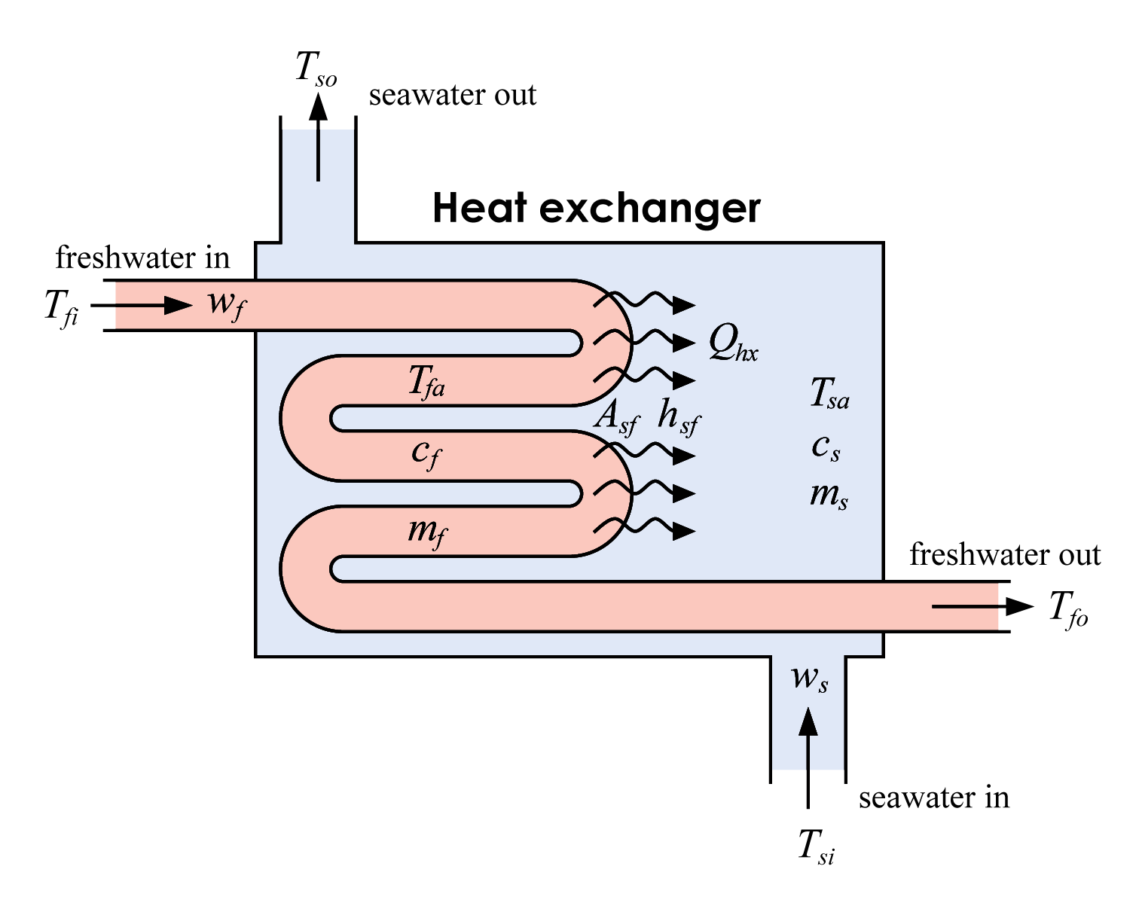
Fig. 1 Fluid heat exchanger

Validity Range and Limitations

N/A

List of Inputs, Outputs, Parameters, and Internal variable

Variable Name | Description | Units
z | Concatenation variable

Input Variable Name | Description | Units
 | Mass flow rate of the freshwater | kg/s
 | mass flow rate of the seawater | kg/s
 | temperature of the incoming freshwater | K
 | temperature of the incoming saltwater | K

Output Variable Name | Description | Units
 | Temperature of the outgoing freshwater | K
 | Temperature of the outgoing seawater | K

Parameter Name | Description | Default Value | Units
 | Surface area of the tube wall |  | m²
 | Heat transfer coefficient between freshwater and seawater | 2536.6 | W/m²/K
 | Specific heat of the freshwater | 4180 | J/kg/K
 | Mass of the freshwater in heat exchanger |  | kg
 | Specific heat of the seawater | 3998 | J/kg/K
 | Mass of the seawater in heat exchanger |  | kg

Internal Variable Name | Description | Units
 | Heat transfer rate from freshwater to seawater | W
p | Time derivative of the temperature of the outgoing freshwater | K/s
p | Time derivative of the temperature of the outgoing seawater | K/s

Macro format

MACRO FluidHeatExchanger(z,wf,tfi,ws,tsi,&
tfo,tso,&
par_Asf,par_hsf,par_cf,par_mf,par_cs,par_ms)

Assumptions in Model Derivation
The heat exchanger is assumed to be well insulated and the fluid flow is assumed to be one dimensional “plug” flow. The model was derived under the practical assumption that the fresh water inlet temperature is always at least as warm as the saltwater inlet temperature. The tube wall is assumed to be thin so that the energy stored in the tube wall can be neglected. As is the case in actual shipboard application, the heat exchanger has a counter flow configuration meaning that the freshwater and seawater flow in opposite directions¹.

Mathematical Description
The heat flow through the heat exchanger cools the incoming fresh water by heating the counter flowing seawater. This heat flow is generally assumed to be a linear function of the Log Mean Temperature Difference (LMTD) between the freshwater and seawater. ^{2, 3}
(1)

where
(2)

However, for fresh water cooling loops, the lumped parameter Log Mean Temperature Difference formulation does not behave well during transient conditions or during saturation. Saturation occurs when the temperature based predicted heat transfer rate exceeds the heat removal capacity of the seawater flow rate. To avoid these problems, the Log Mean Temperature Difference is approximated by the average temperature difference
(3)

In [1], it is shown that the average temperature formulation introduces a 5% percent error if and differ by a factor of two. Extensive testing indicates that errors of this magnitude are negligible compared to the problems created by the introducing saturation and transient behavior into the Log Mean Temperature Difference formulation. Applying conservation of energy to control volumes composed of the freshwater and seawater side of the heat exchanger yields
. (4)

Substituting (1) and into (4) provides
$\begin{aligned}m_{f}c_{f}{\overset{˙}{T}}_{\text{fo}}=w_{f}c_{f}(T_{\text{fi}}−T_{\text{fo}})−Q_{\text{hx}} \\ m_{s}c_{s}{\overset{˙}{T}}_{\text{so}}=Q_{\text{hx}}−w_{s}c_{s}(T_{\text{so}}−T_{\text{si}})\end{aligned}$. (5)

Equations (5) do not account for saturation which occurs when the cooling seawater flow rate is less than the amount required to remove the quantity of heat flow. During saturation, the heat removal is limited to the sum of the heat removed by the seawater plus the net heat required to change the bulk seawater temperature during transient operation as described by
$Q_{\text{hx}}=w_{s}c_{s}(T_{\text{fi}}−T_{\text{si}})+m_{s}c_{s}{\overset{˙}{T}}_{s_{\text{avg}}}≈w_{s}c_{s}(T_{\text{fi}}−T_{\text{si}})+m_{s}c_{s}{\overset{˙}{T}}_{\text{fo}}$. (6)

This saturation results in the following differential equation for the state (5).

$(m_{f}c_{f}+m_{s}c_{s}){\overset{˙}{T}}_{\text{fo}}=w_{f}c_{f}(T_{\text{fi}}−T_{\text{fo}})−w_{s}c_{s}(T_{\text{fi}}−T_{\text{si}})$ (7)

Rearranging (5), (7) and incorporating saturation, provides the final fluid heat exchanger equations

If unsaturated, that is, $A_{\text{sf}}h_{\text{sf}}{ΔT}_{\text{avg}}<w_{s}c_{s}(T_{\text{fi}}−T_{\text{si}})+m_{s}c_{s}{\overset{˙}{T}}_{\text{fo}}$ then
$Q_{\text{hx}}=A_{\text{sf}}h_{\text{sf}}{ΔT}_{\text{avg}}$ and ${\overset{˙}{T}}_{\text{fo}}=\frac{w_{f}c_{f}(T_{\text{fi}}−T_{\text{fo}})−Q_{\text{hx}}}{m_{f}c_{f}}$
Else (saturated)

$Q_{\text{hx}}=w_{s}c_{s}(T_{\text{fi}}−T_{\text{si}})+m_{s}c_{s}{\overset{˙}{T}}_{\text{fo}}$ and ${\overset{˙}{T}}_{\text{fo}}=\frac{w_{f}c_{f}(T_{\text{fi}}−T_{\text{fo}})−w_{s}c_{s}(T_{\text{fi}}−T_{\text{si}})}{m_{f}c_{f}+m_{s}c_{s}}$
For both cases
$${\overset{˙}{T}}_{\text{so}}=\frac{Q_{\text{hx}}−w_{s}c_{s}(T_{\text{so}}−T_{\text{si}})}{m_{s}c_{s}}$$

References
[1] J. Hawley, P. Wiggins, P. Vinning, K. Linder, Thermodynamics of Marine Engineering Systems, Third Edition, Kendall/Hunt Pub., Dubuque, IO, 2000.

[2] M. Horsley, Engineering Thermodynamics, Chapman & Hall, London, 1993.

[3] S. Kakac, H. Liu, Heat Exchangers – Selection, Rating and Thermal Design, CRC Press, Boca Raton, 1998.

