Fresh Water Loop

Author: Y. Lee, E. L. Zivi and A. M. Cramer
Author contact: ylee@usna.edu, zivi@usna.edu
Date: 11 / 27/ 2006
Model name: FreshwaterLoop.mac
Version number: IRIS 1.0
Report errors or changes to: ylee@usna.edu

Brief Description
The freshwater cooling loop circulates freshwater between the “cold plate” component heat exchanger and the fluid heat exchanger. The component heat exchanger removes waste heat from heat producing devices and the freshwater to seawater exchanger dumps the waste heat from the freshwater loop to seawater which is then discharged overboard.

The power component heat exchanger introduced in the previous section is combined with a circulating pump, a supply pile and a return pipe to represent one freshwater cooling fluid loop. As illustrated in Fig. 1, incoming cooling fluid goes through a circulating pump and then travels through the supply pipe to the component heat exchanger. The heated fluid then travels through the return pipe to be cooled by the fluid heat exchanger and returned to the circulating pump.

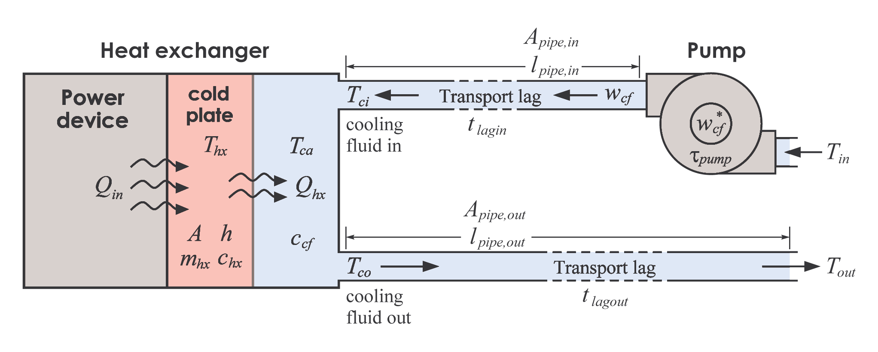
Fig. 1 Fresh water loop

Validity Range and Limitations

N/A

List of Inputs, Outputs, Parameters, and Internal variable

Variable Name | Description | Units
z | Concatenation variable

Input Variable Name | Description | Units
O | Operation status | Logical
$$Q_{\text{in}}$$ | Heat from the power component | W
$T_{\text{in}}$ | Inlet fluid temperature at supply pipe entrance | K

Output Variable Name | Description | Units
$$w_{\text{cf}}$$ | Cooling fluid mass flow rate | kg/s
$$T_{\text{out}}$$ | Outgoing fluid temperature at the pipe exit | K
$$T_{\text{hx}}$$ | Temperature of the cold plate | K

Parameter Name | Description | Default Value | Units
 | Mass of the cold plate |  | Kg
 | Specific heat of the cold plate |  | J/kg/K
 | Specific heat of the cooling fluid |  | J/kg/K
A | Cooling fluid contact area |  | m²
h | Cooling fluid heat transfer coefficient | 4800 | W/ m²/K
$$w_{\text{cf}}^{}$$ | Commanded cooling fluid mass flow rate |  | kg/s
$$l_{\text{pipe},\text{in}}$$ | Inlet pipe length |  | m
$$l_{\text{pipe},\text{out}}$$ | Outlet pipe length |  | m
$$A_{\text{pipe},\text{in}}$$ | Inlet pipe cross-sectional area |  | m²
$$A_{\text{pipe},\text{out}}$$ | Outlet pipe cross-sectional area |  | m²
$$τ_{\text{pump}}$$ | Pump time constant |  | s

Internal Variable Name | Description | Units
$$T_{\text{ci}}$$ | Inlet cooling fluid temperature | K
$$T_{\text{co}}$$ | Outlet cooling fluid temperature | K
$$t_{\text{lagin}}$$ | Transport lag for incoming supply fluid | s
$$t_{\text{lagout}}$$ | Transport lag for outgoing supply fluid | s
p$w_{\text{cf}}$ | Time derivative of cooling fluid mass flow rate | kg/s²

Macro format

MACRO FreshwaterLoop(z,o,qin,tin,&
wcf,tout,thx,&
par_mhx,par_chx,par_ccf,par_A,par_h,par_wcfstar,&
par_Lpipein,par_Lpipeout,par_Apipein,&
par_Apipeout,par_taupump)

Assumptions in Model Derivation
The heat exchanger is assumed to be well insulated and the fluid flow is assumed to be one dimensional “plug” flow.

Mathematical Description
The flow rate is governed by

$$w_{\text{cf}}=\frac{1}{τ_{\text{pump}}s+1}{\left\{\begin{matrix}w_{\text{cf}}^{} & o \\ 0 & \bar{o}\end{matrix}\right.}_{f}$$

where $w_{\text{cf}}^{}$is the nominal mass flow rate of the cooling fluid, o is the operation status of the pump determined in the automation layer, and $τ_{\text{pump}}$is the pump time constant.

The transport lags are calculated using a “plug” flow assumption based on the fluid transit time. The transit time calculation assumes one dimensional incompressible fluid flow through a connection piping leg of characteristic diameter and length

$$t_{\text{lag},x}=\frac{A_{\text{pipe},x}l_{\text{pipe},x}}{q_{f}}$$

where $x∈\left\{\text{in},\text{out}\right\}$, $A_{\text{pipe},x}$is the pipe cross-sectional area, $l_{\text{pipe},x}$is the pipe length, and $q_{f}={w_{\text{cf}}}/ρ$is the volume flow rate where $ρ$is the density of the freshwater.

For zero flow rate, the transport lag becomes infinite which cause an unbounded numerical memory storage problem. To avoid this problem, the transport lag is limited to a maximum value, $t_{\text{lag}\text{,max}}$and if $A_{\text{pipe},x}l_{\text{pipe},x}>q_{f}t_{\text{lag}\text{,max}}$then $t_{\text{lag},x}=t_{\text{lag}\text{,max}}$.

