Power Supply

Macro file name: ps.mac
Macro names: pwsp2, apwsp2
Version number: NCS 3.1

The PS consists of a transformer, a 3-phase controlled rectifier, and a low pass filter to reduce the noise on the output depicted in Fig. 1. In the case of a 3-phase controlled rectifier, the thyristors conduct whenever they are forward biased and the gating signal, delayed by firing angle $α$, is present. The purpose of delaying the gating signal is to regulate the dc voltage level.
The regulatory controller for the PS is responsible to produce the firing angle $α$ and it consists of several stages as shown in Fig. 2. The slew rate limiter and the short circuit protector generate the commanded output voltage $v_{\text{bus}}^{}$. The control blocks accept this signal and the filtered bus voltage $v_{\text{bus}}$ and inductor current $i_{\text{Ldc}}$ to determine the PI and D control signals which are used for generating the firing angle.
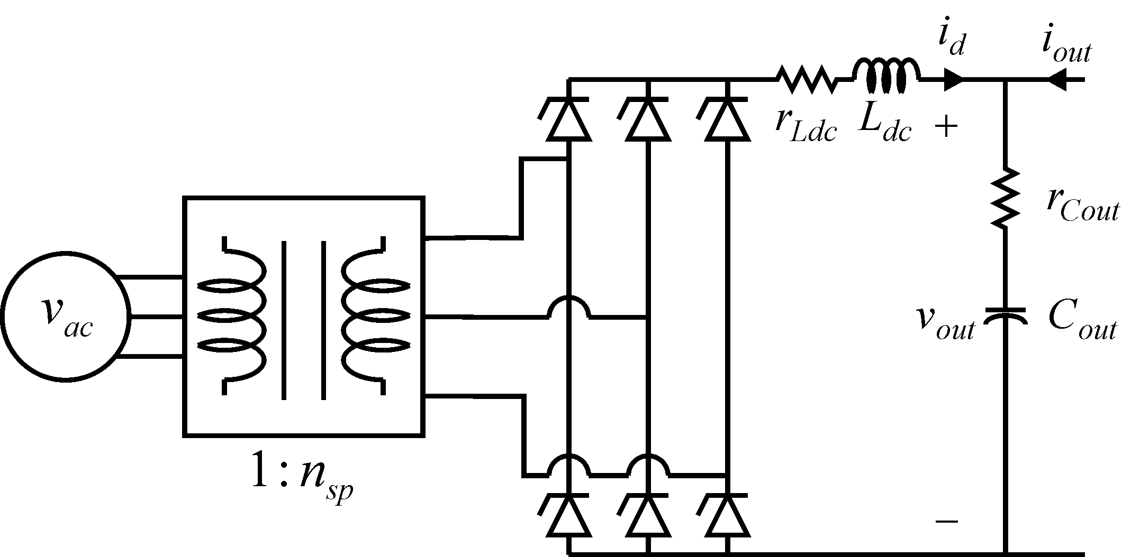
Fig 1. Power supply

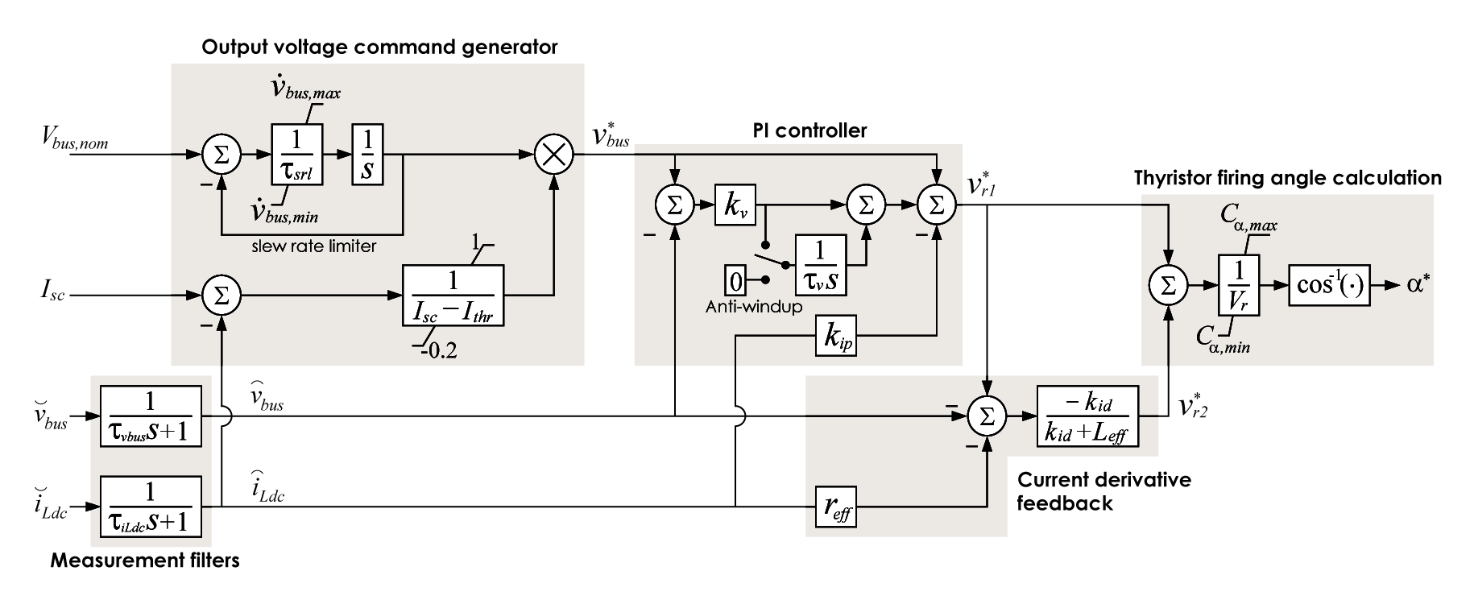
Fig. 2 Power supply control logic

PWSP2 : detailed model

Author: S. D. Sudhoff
Author contact: sudhoff@purdue.edu,
Date:
Macro name: pwsp2
Version number: NCS 3.1
Report errors or changes to: sudhoff@purdue.edu

Brief Description

Detailed model of the power supply.

Validity Range and Limitations

N/A

List of Inputs, Outputs, Parameters, and Internal variable

Variable Name | Description | Units
z | Concatenation variable

Input Variable Name | Description | Units
$v_{\text{qps}}^{p}$ | q-axis stationary reference frame voltage | V
$v_{\text{dps}}^{p}$ | d-axis stationary reference frame voltage | V
$ε^{}$ | Enable power supply | logical
$u_{\text{in}}$ | Power supply output voltage OR  Output current into power supply (see mdcnfg) | V  A

Output Variable Name | Description | Units
$i_{\text{qps}}^{p}$ | q-axis stationary reference frame current into power supply | A
$i_{\text{dps}}^{p}$ | d-axis stationary reference frame current into power supply | A
$u_{\text{out}}$ | power supply output current (into supply) OR output voltage (See mdcnfg) | A  V
$V_{\text{outthev}}$ | Instantaneous Thevenin equivalent output voltage | V
$r_{\text{outthev}}$ | Instantaneous Thevenin equivalent resistance | Ω

Parameter Name | Description | Default Value | Units
mdcnfg | Model configuration  1: $u_{\text{in}}$ = power supply output voltage (V)  $u_{\text{out}}$= power supply output current (into supply) (A)  2: $u_{\text{in}}$ = power supply output current (into supply) (A)  $u_{\text{out}}$= power supply output voltage (V)
Transformer
$L_{\text{lp}}$ | Transformer primary side leakage inductance |  | H
$r_{p}$ | Transformer primary side resistance |  | Ω
$L_{\text{ls}}$ | Transformer secondary side leakage inductance |  | H
$r_{s}$ | Transformer secondary side resistance |  | Ω
$L_{m}$ | Transformer magnetizing inductance |  | H
$n_{\text{sp}}$ | Secondary to primary turns ratio
Rectifier
$r_{\text{lo}}$ | SCR on state resistance |  | Ω
$r_{\text{hi}}$ | SCR off state gain resistance |  | Ω
Output filter
$$L_{\text{dc}}$$ | DC link inductor inductance |  | H
$$r_{\text{dc}}$$ | DC link inductor resistance |  | Ω
$$C$$ | Capacitance of the output capacitor |  | F
$$r_{C}$$ | Effective series resistance of output capacitor |  | Ω
Gate control
$ω_{e\text{exp}}$ | Expected fundamental input frequency |  | rad/s
$τ_{\text{60}}$ | Time constant to cause fundamental frequency to shift by 60 degrees in a low pass filter |  | sec.
$τ_{\text{SCRoff}}$ | Time after SCR gated on that it is gated off |  | sec.
Control
$v_{o}^{}$ | Unloaded output voltage |  | V
$$i_{\text{thr}}$$ | Threshold current |  | A
$$i_{\text{sc}}$$ | Desired short circuit current |  | A
p$v_{\text{out}\text{max}}$ | Maximum slew rate for the bus voltage |  | V/s
p$v_{\text{out}\text{min}}$ | Minimum slew rate for the bus voltage |  | V/s
$$τ_{\text{srl}}$$ | Time constant of slew rate limiter |  | sec.
$τ_{\text{vout}}$ | Output voltage measurement time constant |  | sec.
$τ_{\text{id}}$ | Output current measurement time constant |  | sec.
$$k_{v}$$ | Proportional gain for PI controller |  | 1/V
$$τ_{v}$$ | Voltage control integral time constant |  | sec.
$$k_{\text{ip}}$$ | DC link current feedback gain |  | V/A
$$k_{\text{id}}$$ | DC link current derivative feedback gain |  | Vs/A
$v_{r0}$ | Lightly loaded rectifier output voltage |  | V
$$C_{α\text{min}}$$ | Minimum bound for the firing angle |  | rad
$$C_{α\text{max}}$$ | Maximum bound for the firing angle |  | rad
$r_{\text{eff}}$ | Effective dc link resistance |  | Ω
$L_{\text{eff}}$ | Effective dc link inductance |  | H

Internal Variable Name | Description | Units
$$i_{q\text{sec}}$$ | q-axis current into transformer secondary | A
$$i_{d\text{sec}}$$ | d-axis current into transformer secondary | A
$$v_{q\text{sec}}$$ | q-axis transformer secondary voltage | V
$$v_{d\text{sec}}$$ | d-axis transformer secondary voltage | V
$$v_{\text{ar}}$$ | a-phase rectifier to bottom rail voltage | V
$$v_{\text{br}}$$ | b-phase rectifier to bottom rail voltage | V
$$v_{\text{cr}}$$ | c-phase rectifier to bottom rail voltage | V
$$i_{\text{ar}}$$ | a-phase current into rectifier | A
$$i_{\text{br}}$$ | b-phase current into rectifier | A
$$i_{\text{cr}}$$ | c-phase current into rectifier | A
$$v_{d}$$ | rectifier output voltage | V
$$i_{d}$$ | rectifier output current | A
p$i_{d}$ | rectifier output current | A
$$v_{c}$$ | voltage across capacitive element of output capacitor | V
p$v_{c}$ | Time derivative of $v_{c}$ | A
$$v_{\text{apri}}$$ | a-phase primary line-to-neutral voltage | V
$$v_{\text{bpri}}$$ | b-phase primary line-to-neutral voltage | V
$$v_{\text{cpri}}$$ | c-phase primary line-to-neutral voltage | V
$$v_{\text{abpri}}$$ | a- to b-phase primary voltage | V
$$v_{\text{bcpri}}$$ | b- to c-phase primary voltage | V
$$v_{\text{capri}}$$ | c- to c-phase primary voltage | V
$$G_{1}$$ | Rectifier valve 1 gating signal | logical
$$G_{2}$$ | Rectifier valve 2 gating signal | logical
$$G_{3}$$ | Rectifier valve 3 gating signal | logical
$$G_{4}$$ | Rectifier valve 4 gating signal | logical
$$G_{5}$$ | Rectifier valve 5 gating signal | logical
$$G_{6}$$ | Rectifier valve 6 gating signal | logical

Macro format

MACRO pwsp2(z,vqpps,vdpps,epsstar,uin, &
iqpps,idpps,uout,voutthev,routthev, &
par_mdcnfg, &
par_llp,par_rp,par_lls,par_rs,par_lm,par_nsp, &
par_rlo,par_rhi, &
par_ldc,par_rdc,par_c,par_rc, &
par_weexp,par_tau60,par_tscroff, &
par_vstar0,par_ithr,par_isc, &
par_pvoutmax,par_pvoutmin,par_tausrl, &
par_tauvout,par_tauid, &
par_kv,par_tauv,par_kip,par_kid,par_vr0, &
par_camx,par_camn,par_reff,par_leff)

Validation
This model has been validated via hardware experimentations.

APWSP2 : Nonlinear average value model

Author: S. D. Sudhoff
Author contact: sudhoff@purdue.edu,
Date:
Macro name: pwsp2
Version number: NCS 3.1
Report errors or changes to: sudhoff@purdue.edu

Brief Description
Nonlinear average value model of the power supply.

Validity Range and Limitations

N/A

List of Inputs, Outputs, Parameters, and Internal variable

Variable Name | Description | Units
z | Concatenation variable

Input Variable Name | Description | Units
$v_{\text{qps}}^{p}$ | q-axis stationary reference frame voltage | V
$v_{\text{dps}}^{p}$ | d-axis stationary reference frame voltage | V
$$ω_{g}$$ | bus frequency | rad/s
$ε^{}$ | Enable power supply | logical
$u_{\text{in}}$ | Power supply output voltage OR  Output current into power supply (see mdcnfg) | V  A

Output Variable Name | Description | Units
$i_{\text{qps}}^{p}$ | q-axis stationary reference frame current into power supply | A
$i_{\text{dps}}^{p}$ | d-axis stationary reference frame current into power supply | A
$u_{\text{out}}$ | power supply output current (into supply) OR output voltage (See mdcnfg) | A  V
$V_{\text{outthev}}$ | Instantaneous Thevenin equivalent output voltage | V
$r_{\text{outthev}}$ | Instantaneous Thevenin equivalent resistance | Ω

Parameter Name | Description | Default Value | Units
mdcnfg | Model configuration  1: $u_{\text{in}}$=power supply output voltage (V)  $u_{\text{out}}$=power supply output current (into supply) (A)  2: $u_{\text{in}}$=power supply output current (into supply) (A)  $u_{\text{out}}$=power supply output voltage (V)
Transformer
$L_{\text{lp}}$ | Transformer primary side leakage inductance |  | H
$r_{p}$ | Transformer primary side resistance |  | Ω
$L_{\text{ls}}$ | Transformer secondary side leakage inductance |  | H
$r_{s}$ | Transformer secondary side resistance |  | Ω
$L_{m}$ | Transformer magnetizing inductance |  | H
$n_{\text{sp}}$ | Secondary to primary turns ratio
Rectifier
$r_{\text{scr}}$ | SCR on state resistance |  | Ω
$v_{\text{scr}}$ | SCR on state voltage drop |  | V
Output filter
$$L_{\text{dc}}$$ | DC link inductor inductance |  | H
$$r_{\text{dc}}$$ | DC link inductor resistance |  | Ω
$$C$$ | Capacitance of the output capacitor |  | F
$$r_{C}$$ | Effective series resistance of output capacitor |  | Ω
Gate control
$τ_{\text{60}}$ | Time constant to cause fundamental frequency to shift by 60 degrees in a low pass filter |  | sec.
Control
$v_{o}^{}$ | Unloaded output voltage |  | V
$$i_{\text{thr}}$$ | Threshold current |  | A
$$i_{\text{sc}}$$ | Desired short circuit current |  | A
p$v_{\text{out}\text{max}}$ | Maximum slew rate for the bus voltage |  | V/s
p$v_{\text{out}\text{min}}$ | Minimum slew rate for the bus voltage |  | V/s
$$τ_{\text{srl}}$$ | Time constant of slew rate limiter |  | sec.
$τ_{\text{vout}}$ | Output voltage measurement time constant |  | sec.
$τ_{\text{id}}$ | Output current measurement time constant |  | sec.
$$k_{v}$$ | Proportional gain for PI controller |  | 1/V
$$τ_{v}$$ | Voltage control integral time constant |  | sec.
$$k_{\text{ip}}$$ | DC link current feedback gain |  | V/A
$$k_{\text{id}}$$ | DC link current derivative feedback gain |  | Vs/A
$$v_{r0}$$ | Lightly loaded rectifier output voltage |  | V
$$C_{α\text{min}}$$ | Minimum bound for the firing angle |  | rad
$$C_{α\text{max}}$$ | Maximum bound for the firing angle |  | rad
$$r_{\text{eff}}$$ | Effective dc link resistance |  | Ω
$$L_{\text{eff}}$$ | Effective dc link inductance |  | H

Internal Variable Name | Description | Units
$$L_{c}$$ | Commutating inductance | H
$$α_{t}$$ | Turns ratio to put all leakage ind. on secondary side | V
$$r_{\text{Lc}}$$ | Total (ref. primary plus secondary) resistance | Ω
$$v_{\text{qp},\text{psa}}$$ | referred q-axis prim side power supply voltage | V
$$v_{\text{dp},\text{psa}}$$ | referred d-axis prim side power supply voltage | V
$$i_{\text{qs}}$$ | secondary q-axis current into power supply | A
$$i_{\text{ds}}$$ | secondary d-axis current into power supply | A
$$α^{}$$ | Commanded firing angle command | rad
$$α_{\text{eff}}^{}$$ | Effective firing angle command | rad
$$r_{\text{Lc}}$$ | Effective DC link resistance | Ω
mode | Rectifier mode
$$v_{d}$$ | Rectifier output voltage | V
$$i_{d}$$ | Rectifier output current | A
$$v_{c}$$ | Voltage across capacitive element of output capacitor | V
p$v_{c}$ | Time derivative of $v_{c}$ | V/s

Macro format

MACRO apwsp2(z,vqpps,vdpps,wg,epsstar,uin, &
iqpps,idpps,uout,voutthev,routthev, &
par_mdcnfg, &
par_llp,par_rp,par_lls,par_rs,par_lm,par_nsp, &
par_rscr,par_vscr, &
par_ldc,par_rdc,par_c,par_rc, &
par_tau60, &
par_vstar0,par_ithr,par_isc, &
par_pvoutmax,par_pvoutmin,par_tausrl, &
par_tauvout,par_tauid, &
par_kv,par_tauv,par_kip,par_kid,par_vr0, &
par_camx,par_camn,par_reff,par_leff)

Mathematical Description

The PS dynamics may be expressed as

${\text{pi}}_{d}=\frac{V_{r}\text{cos}\left(α\right)−r_{\text{eff}}i_{d}−v_{\text{out}}}{L_{\text{eff}}}$ (1)
and
${\text{pv}}_{\text{Cout}}=\frac{v_{\text{out}}−v_{\text{Cout}}}{C_{\text{out}}r_{\text{Cout}}}$, (2)

where
$V_{r}=3\sqrt{6}E/π$ , (3)
$r_{\text{eff}}=r_{\text{dc}}+3l_{c}{ω_{g}}/π$, (4)
and
$L_{\text{eff}}=L_{\text{dc}}+2l_{c}$. (5)

In (Error: Reference source not found)-(Error: Reference source not found) $E$ is the rms l-n amplitude of the ac input and $l_{c}$ is the commutating inductance of the transformer as seen by the secondary. Note that $i_{d}$ and $v_{\text{Cout}}$ are positive quantities due to the nature of the thyristors and the use of electrolytic capacitors. Interested readers are referred to [1, Chapter 11] for the derivation of the average value model of the PS.

Validation
This model has been validated via hardware experimentations.

Reference
[1] P.C. Krause, O. Wasynczuk, and S.D. Sudhoff, Analysis of Electric Machinery and Drive Systems, 2nd ed., John Wiley and Sons/IEEE Press, New York, 2002.

