Component Heat Exchanger

Author: Y. Lee, E. L. Zivi and A. M. Cramer
Author contact: ylee@usna.edu, zivi@usna.edu
Date: 9 / 22/ 2006
Model name: ComponentHeatExchanger.mac
Version number: IRIS 1.0
Report errors or changes to: ylee@usna.edu

Brief Description
Power component heat dissipation is removed through conduction from the power components to a “cold plate” heat sink. This cold plate is then cooled via convective heat transfer to a cooling fluid as illustrated in the figure 1. Typically the cooling fluid is saltwater (seawater), freshwater, or chilled water.
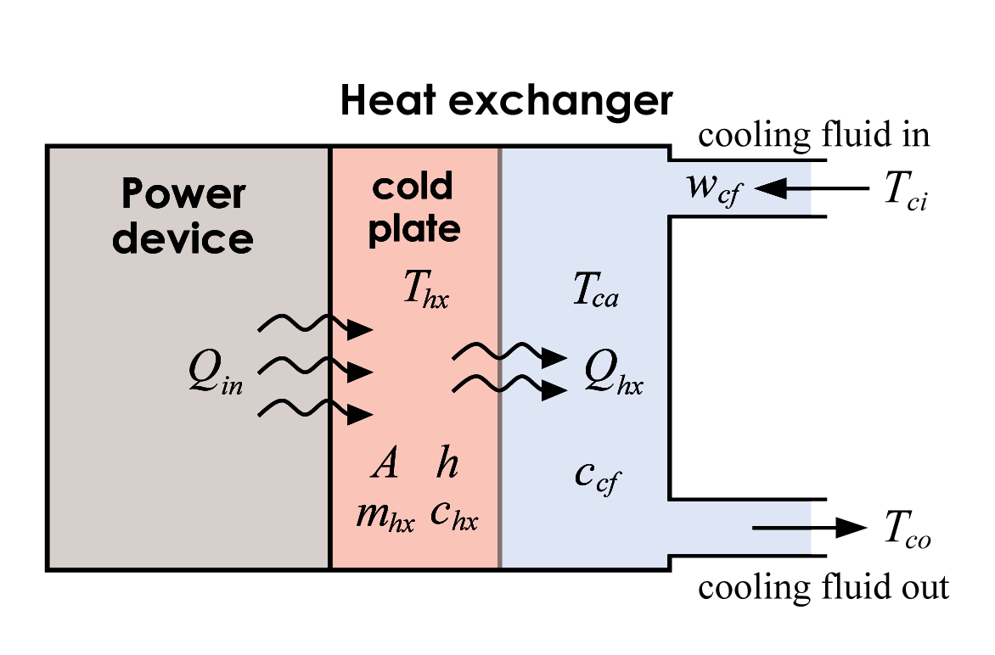
Fig 1. Cold plate heat exchanger

Validity Range and Limitations

N/A

List of Inputs, Outputs, Parameters, and Internal variable

Variable Name | Description | Units
z | Concatenation variable

Input Variable Name | Description | Units
 | Heat transfer rate from the component | W
 | Mass flow rate of the cooling fluid | kg/s
 | Temperature of the incoming flukd | K

Output Variable Name | Description | Units
 | Temperature of the outgoing fluid | K
 | Temperature of the cold plate | K

Parameter Name | Description | Default Value | Units
 | Mass of the cold plate |  | Kg
 | Specific heat of the cold plate |  | J/kg/K
 | Specific heat of the cooling fluid |  | J/kg/K
A | Cooling fluid contact area |  | m²
h | Cooling fluid heat transfer coefficient | 4800 | W/ m²/K

Internal Variable Name | Description | Units
 | Heat transfer rate from the cold plate to fluid | W
p | Time derivative of the temperature of the cold plate | K/s

Macro format

MACRO ComponentHeatExchanger(z,qin,wcf,tci,&
tco,thx,&
par_mhx,par_chx,par_ccf,par_A,par_h)

Assumptions in Model Derivation
The power component heat dissipation is determined from the power component efficiency
(1)
Heat source parameter
power component efficiency (dimensionless)
Heat source input
component power (W)
Heat source output
heat flow from the power component (W = J/s)

Note that this formulation for is independent of the cold plate temperature and the thermal resistance between the power components and the cold plate. These assumptions are consistent with the customary deactivation of power components from excessive cold plate temperature.

The heat exchanger is assumed to be well insulated and the fluid flow is assumed to be one dimensional “plug” flow.

Mathematical Description
The net heat flow into the heat exchanger cold plate is the difference between the heat flow from the power components and the heat flow removed by the cooling fluid. This net heat flow determines the cold plate rate of temperature change
${\text{pT}}_{\text{hx}}=\frac{Q_{\text{in}}−Q_{\text{hx}}}{m_{\text{hx}}c_{\text{hx}}}$ (2)

The heat flow from the cold plate to the cooling fluid is governed by the convective heat transfer from the cold plate to the cooling fluid
$Q_{\text{hx}}=\text{Ah}(T_{\text{hx}}−T_{\text{ca}})$ (3)
where $T_{\text{ca}}$ is the average fluid temperature.

From conservation of energy, the heat flow removed by the cooling fluid can be specified in terms of flow rate, specific heat and fluid heating as
. (4)

Neglecting transient fluid thermodynamics along the interior of the heat exchanger produces a lumped parameter fluid model wherein and the average fluid temperature is
(5)

Substituting (5) into (3) provides the cold plate to cooling fluid heat transfer rate in terms of inlet and outlet fluid temperatures
$Q_{\text{hx}}=\text{Ah}\left(T_{\text{hx}}−\frac{T_{\text{ci}}+T}{2}\right)$ (6)

Rearranging (6) yields the outlet temperature of the cooling fluid as
$T_{\text{co}}=2\left(T_{\text{hx}}−\frac{Q_{\text{hx}}}{\text{Ah}}\right)−T_{\text{ci}}$ (7)

Using the approximation, (4) can be rearranged so that
. (8)

Substituting (8) into (6) yields the heat transfer rate in terms of the cold plate temperature, inlet cooling fluid temperature and flow rate
$Q_{\text{hx}}=\frac{2w_{\text{cf}}c_{\text{cf}}\text{Ah}}{2w_{\text{cf}}c_{\text{cf}}+\text{Ah}}\left(T_{\text{hx}}−T_{\text{ci}}\right)$ (9)

However, this formulation is only valid if the cooling fluid flow rate is sufficient so that the heat transfer rate to the fluid, , does not exceed the cooling fluid heat removal capacity defined by constraining (4) to . If the cooling fluid heat removal capacity is saturated, then and from (4)
. (10)

Comparing (6) and (9) at the boundary condition provides a convenient test to ensure that the heat transfer to the fluid does not exceed the heat removal capacity of the fluid
$2w_{\text{cf}}c_{\text{cf}}≥\text{Ah}$. (11)

In summary, (2),(7),(9), (10) and (11) provide the final cold plate heat exchanger thermal model including thermal saturation.

${\text{pT}}_{\text{hx}}=\frac{Q_{\text{in}}−Q_{\text{hx}}}{m_{\text{hx}}c_{\text{hx}}}$ where if $2w_{\text{cf}}c_{\text{cf}}≥\text{Ah}$ then $Q_{\text{hx}}=\frac{2w_{\text{cf}}c_{\text{cf}}\text{Ah}}{2w_{\text{cf}}c_{\text{cf}}+\text{Ah}}\left(T_{\text{hx}}−T_{\text{ci}}\right)$
and
else and

