Project: Simulation Environment for Dynamic Thermal Modeling
Project Completion: 2009
Output: Proof of concept demonstration of the simulation environment for the Dynamic Thermal Modeling and Simulation (DTMS) [1]
Outcome: The Simulation Environment developed specifically for the Onboard Fire and Smoke Propagation models has been generalized to support other simulation packages targeted to model different aspects of an electric ship design. The Simulation Environment could become a platform for transferring research simulation codes into operations. A model, developed and tested in an academic environment, could be operated by the customer, such as a shipyard or Navy facility with proprietary or otherwise restricted-access data, without assistance of the code developer.

Project Motivation: The collaborative work of the Naval Research Laboratory (NRL), Mississippi State University (MSU), and Hughes Associates, Inc. (HAI) resulted in the development of a simulation system (“FireGUI”) for simulating onboard fire and smoke propagation [2,3]. The intent of the FireGUI is to assist ship designers in studying the spread of fire, smoke, and toxic elements on ships or submarines, to serve as a training tool for firefighters, and to be used as a tactical tool taking advantage of the FireGUI’s capability to generate faster than real-time predictions. The FireGUI has been extensively used by the NRL’s Navy Technology Center for Safety and Survivability to replace costly physical experiments on the ex-USS Shadwell by numerical simulations, saving millions of taxpayers’ dollars.

The cost savings and other benefits of numerical simulations are well known and undeniable. However, the complexity of new codes developed by the industry, and in particular by academia makes their transition to the operational environment of the U.S. Navy and/or shipbuilding industry extremely difficult. The Simulation Environment provides a solution to this problem. The HAI’s FSSIM model is now easy to operate given the geometry of a ship. The same can be done for simulation packages pertaining to other shipboard systems. To this end, ESRDC collaborators have made rapid progress with building a user-friendly environment for the Dynamic Thermal Modeling and Simulation (DTMS) and for simulations of configurable onboard power systems.

The DTMS Framework is a modeling and simulation platform designed for system-level thermal simulations of indefinitely large shipboard systems. DTMS supports a customizable input/output system designed to allow it to be easily integrated with external platforms and systems. In particular, the DTMS framework features:
- System-level modeling and simulation design of thermal shipboard systems
- Straightforward modeling technique to allow rapid and independent model development
- Support for multiple, user-defined simulation and solution methods
- Multiple fluid support, including two-phase correlations and solving techniques
- Tracking of multiple system properties, including temperatures, pressures, flow rates, and efficiencies.

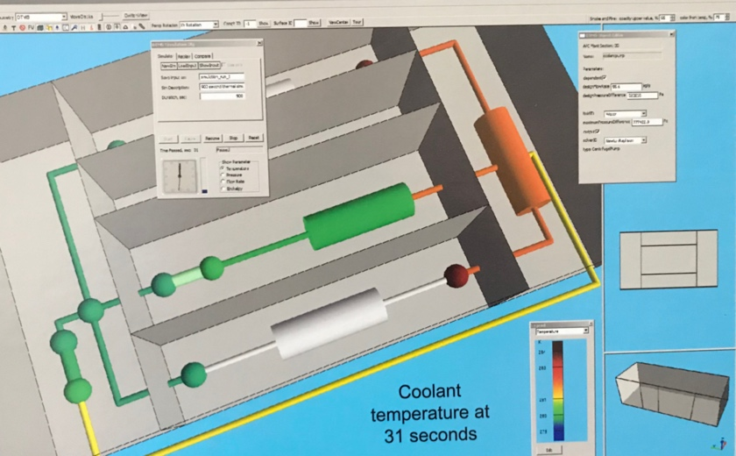
The Simulation environment imports the geometry of the ship as well as positions of elements of the thermal system from a data base and generates a 3D view of the ship. The view can be zoomed, rotated, and translated. Furthermore, the decks of the ship can be separated for better interior views. Alternatively, the ship can be displayed as floor plans for each deck, side by side, and in addition, each compartment can be viewed (zoomed, rotated, etc.) independently. The model setup (i.e., model parameters and component properties) is performed by simple point-and-click operations. Once the model setup is completed, the DTMS input deck is automatically generated and the simulation is started. The simulations can be saved for a rapid replay or to compare with simulations run with different parameters.
Figure 1. Example of a DTMS run using the Simulation Environment. Here, the components of the thermal systems are colored by the temperature of the coolant at given times.
The future steps with the development of the Simulation Environment involve developing support for importing the ship geometry, material properties, and component properties directly from LEAPS databases and delegating the execution of the models to High-Performance Computing platforms. We expect that this work will become an inspiration for the S3D developers.
This work was presented at the 2009 ESTS conference [4].
[1] T. Kiehne, M. P. Pirece, “User’s Guide and Tutorial for the Dynamic Thermal Modeling and Simulation (DTMS) Framework”, UT Austin,
November 2008, unpublished
[2] G. Henley. T. A. Haupt, B. Parihar, F. W. Williams, “FireGUI: A Software Tool for Predicting Fire and Smoke Spread on Ships”, ASNESymposium: Shipbuilding in Support of the Global War on Terrorosim, Apr 14-17, 2008, Biloxi, MS
[3] T A. Haupt , G. Henley, B. Sura, R. Kirkland, J. Floyd, J. Scheffey, P.A. Tatem, F. W. Williams, “User Manual for Graphical User Interface
Version 2.4 with Fire ans Smoke Simulation Model (FSSIM) Version 1.2, NRL Technical Report NRL/MR/6180—06-9013, Washington,
DC, 2006.

[4] T. Haupt, G. Henley, B. Parihar, N. Shultz, “Simulation Environment for Onboard Subsystems of an Electric Ship”, Electric Ship Technologies Symposium, 2009. ESTS 2009. IEEE

Project Extent: This project involved researchers from two ESRDC member institutions and is documented in several technical papers.
The core capabilities of the Simulation Environment was funded by Naval Research Lab, independently from the ESRDC activities.
Technical Point of Contact: Dr. T. Haupt, haupt@cavs.msstate.edu

